Preparing a Remindo Exam for students that use the Readspeaker (text-to-voice) plugin.

Sometimes you will have a student in your exam that uses the “Readspeaker” text-to-speech option in Remindo. This document provides a checklist that can help you prepare the exam for this situation.

- When building questions: Set the proper question language in the question database.

The language setting of questions determines the language in which the question text is read to a student by the Readspeaker plugin. How can you check/adjust the language setting of a question?

- Individual questions:
In your question database you see the set language right of the questions.

To change the language, click on the question and below in the screen now select the ‘settings’ tab. There you can change the language and save the question.

- Bulk/ multiple questions:
In your question database, select all questions for which you want to change the language setting.

- Left in the screen you see a shopping basket and a lightning symbol:
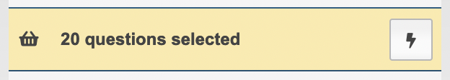
- Click on the lightning symbol, in the next screen select “Change the settings..” by clicking on the gears-symbol
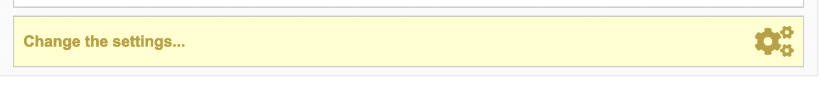
- In the next pop-up screen, select the preferred language:
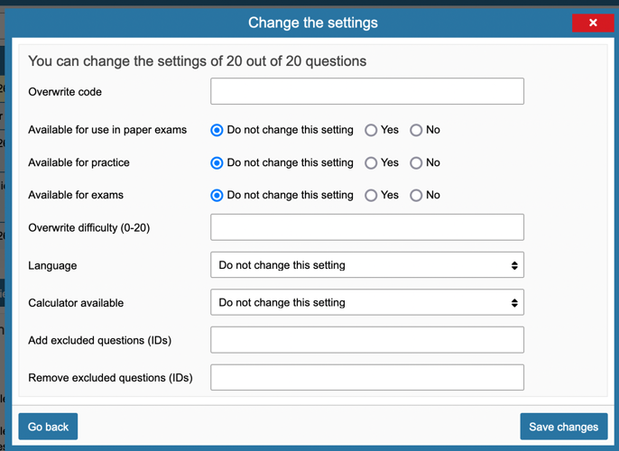
- Click “Save changes” to set the new language settings.

- Don’t use Roman numerals in questions and answering options.
Roman numerals will be pronounced as letters by the system, not as a number. This applies for instance to statement questions. Preferably use real numbers, f.i.: “statement 1 is true, statement 2 is false”

- What cannot be read by the plugin: Images
This concerns all types of images (Content of images, Tables added as images, Text added as images (for instance a scan of a newspaper item)).
Advice: Give images in questions a Description, this description is then read to the students when they select the image with the Readspeaker plugin.
To set the description, select a question with the picture in it and click on “edit the question”, then click on the picture, the add/edit media button will turn black: .
Click on that button again, you will see the next screen where you can add the description:
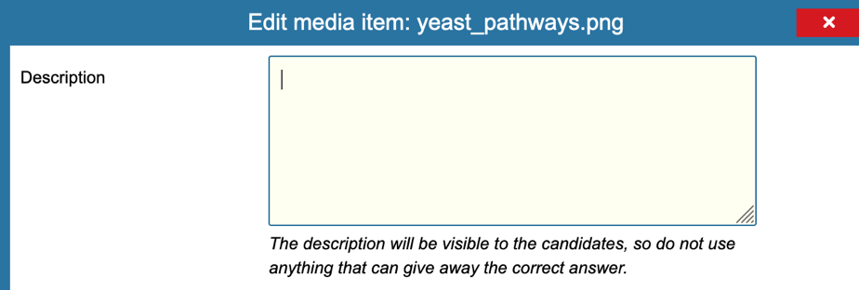

- When adding pdf’s to your test, try to add only the material needed and pdf’s with English text are not allowed. Extra pages (and tables) in the pdf cause extra load time for students that use the Readspeaker plugin. Important notice: Due to an existing bug, English text in the pdf is read in Dutch. Therefore only pdf’s with Dutch text are allowed

- Check the exam with Readspeaker turned on.
You can also ask your key-user to turn on the Readspeaker option for you, so you can walk through the exam preview and check with the Readspeaker plugin yourself.

Additional information:
- Students with the ‘provision’ ‘text-to-speech’ always have the option to use the plugin in Remindo, as long as the provision is allocated to them by the study-advisors.
- Facultary key-users can set the Readspeaker-plugin availability for students.
- The Readspeaker plugin is built into Remindo and is available both for tests on location as well as for off-campus tests in Remindo. No special laptops have to be arranged for the use of Readspeaker. The regular chromebooks can be used instead.

