Concise releasenotes Release 21.5 of Remindo
These notes are to inform you as teacher/professor about relevant adjustments as a result from the Release 21-5 of Remindo
Management environment
- (optimalisation) There were some issues with the composition of a test matrix when many question properties were used in an environment. We have made the necessary adjustment so that the test matrix can be made and saved.
Test taking environment (student)
- It is now possible to drag the screen in which PDF-files are opened during a test across the screen, so that students are able to have both the question and the PDF on their screen simultaneously.
Test taking environment (teacher)
- More options have been added to the ‘Activity overview’ for sorting the list of candidates (see screenshot). Now it is possible to sort faster and more efficiently, also in the fields that are not set in the heading of the table with students.
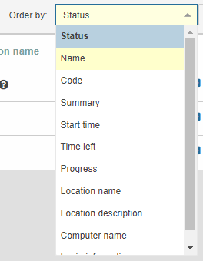
- On top of the ID of a question, the version is also mentioned in the analysis of a test for which adjustments have been made in a question’s correction model.
- There have been a few improvements in the overview page for checking answers, which can be found through Results > Check answers. Now it is possible to navigate faster to the desired information.
  - Instead of 2 tabs, now 4 tabs will appear when opening the page. This is because now a distinction is made between recipes/test moments that have yet to be checked, and recipes/test moment that have already been checked.
  - Each of these 4 tabs now contains a filter to select the recipes or test moment, as well as the period.
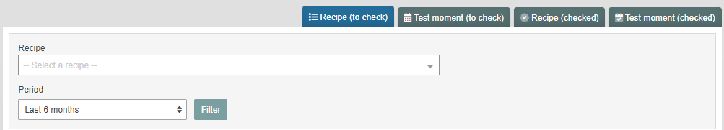
  - The column ’Added on’ has been added to the overview. This column is standardly used for sorting, so that the most recent corrections are at the top of the overview.
- When you go on to view correction work from this page, a filter will be present at the top of the page, which makes it possible to find specific candidates.
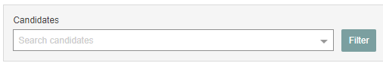
- The correction model to an open question can now be altered at any time – even when the correction process hasn’t been started yet.

