Concise releasenotes Release 22.1 of Remindo
With these notes we inform you as a teacher of new relevant changes from the Release 22.1 of Remindo.
Test-taking environment (student)
- When a student is allowed to view the correct answers after doing a Practice, they will now see this directly after answering the question, during the feedback, as well.
Planning
- The option ‘Let candidates compare themselves to others’ has been added to the visibility for the student when planning a new test. This option allows students to compare themselves/their own group to one or multiple other groups, when they are assigned to candidate groups.
Results
- The option of viewing a group analysis has been added to the Analysis function. A new tab has been added.
The group analysis allows for the comparison of candidates, who have been assigned to candidate groups, at group level. Moreover, the option allows for comparison between candidate groups.
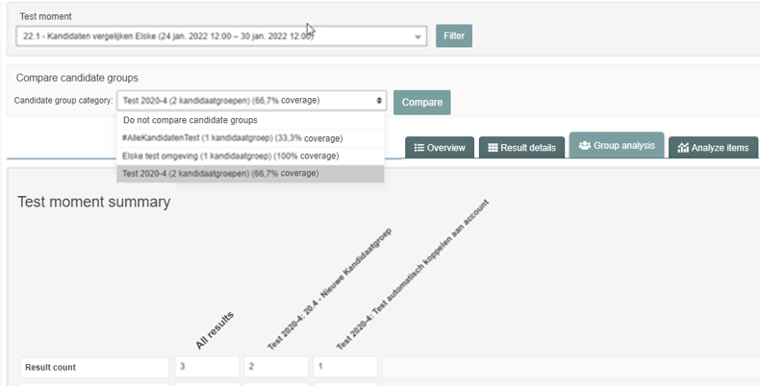
- Feedback doesn’t have its own tab anymore, but can be filtered under the tab ‘Result details’.

